Message templates

Message templates define the layout, content, and formatting of automated messages sent from your store. They are called transactional emails because each one is associated with a specific type of transaction.

There are several message templates available in nopCommerce by default to notify users and the store owner about order statuses and more. To access message templates, go to **Content management → Message templates**.

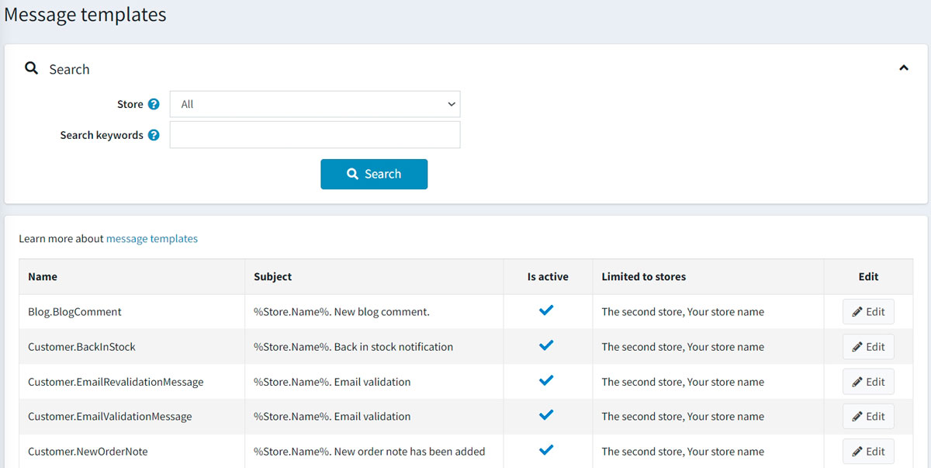

You can search for message templates by keywords or store. Keywords are used to search in the name, body or subject of a message template. The list of available stores is shown if you have more than one store and the **Performance → Ignore "limit per store" rules (sitewide)** setting on the *Catalog settings* page is not active.

Edit a message template

Find the message template you want to edit and click **Edit**. The *Edit message template details* window will be displayed as follows:

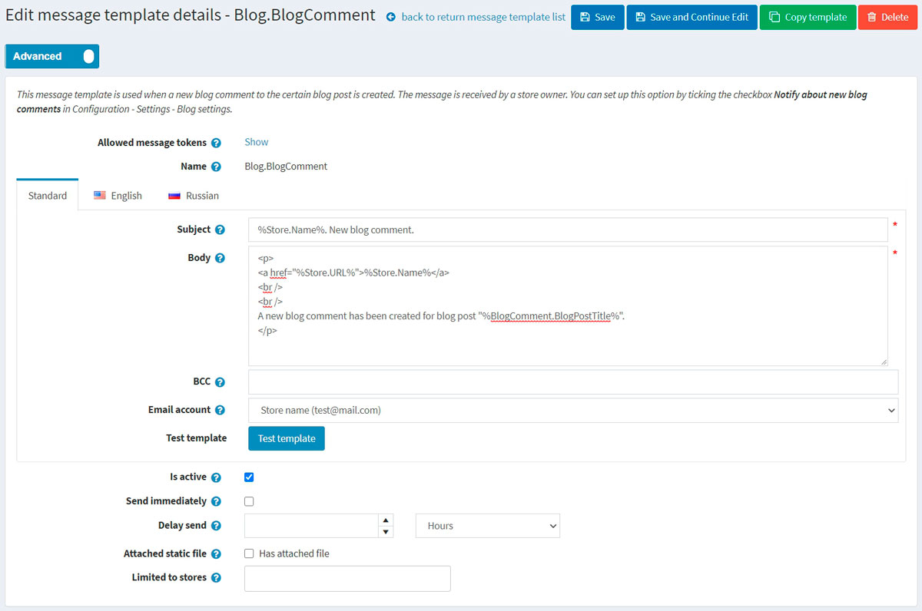

If you have more than one language installed, select the required **language tab**.

**TIP**

By default, only the English language is used in the system. You can manage languages in **Configuration → Language**. Read more about languages in nopCommerce in the [Localization](https://docs.nopcommerce.com/en/getting-started/advanced-configuration/localization.html) section.

Edit the message template details as follows:

* Edit the **Subject** of the message. You can include tokens in the subject. You can see the list with all the tokens allowed at the top of the page.
* Edit the **Body** of the message.
* In the **BCC** field, enter the blind copy recipients of this email message if needed.
* From the **Email account** dropdown list, select the email account used to send this message template.
* You can test this message template by clicking the **Test template** button. When clicked, the *Send test email* will be displayed as follows: 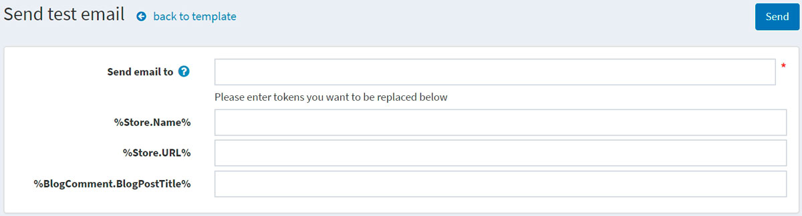 Enter your email in the **Send email to** field, fill the tokens with some test values, then click the **Send** button.

**TIP**

Email accounts are configured in **Configuration → Email accounts**. Read more about it in the [Emails accounts](https://docs.nopcommerce.com/en/getting-started/email-accounts.html) section.

* Select the **Is active** option to indicate this message should be sent.
* Select the **Send immediately** checkbox if you want this email to be sent immediately.
  + If the previous checkbox is clear, the **Delay send** field will be displayed.
* Select the **Attached static** file checkbox to upload a file that will be attached to each email sent.
* Choose the stores in the **Limited to stores** field if the message template is for specific stores only. Leave the field empty in case this functionality is not required.

**NOTE**

In order to use this functionality, you have to disable the following setting: **Catalog settings → Ignore "limit per store" rules (sitewide)**. Read more about multi-store functionality [here](https://docs.nopcommerce.com/en/getting-started/advanced-configuration/multi-store.html).

Click **Save**.

**NOTE**

To create a full copy of the message template, click **Copy template** in the top right. This is useful if you have several stores configured and want to create distinct templates for each of your stores.